**CURRICULUM VITAE**

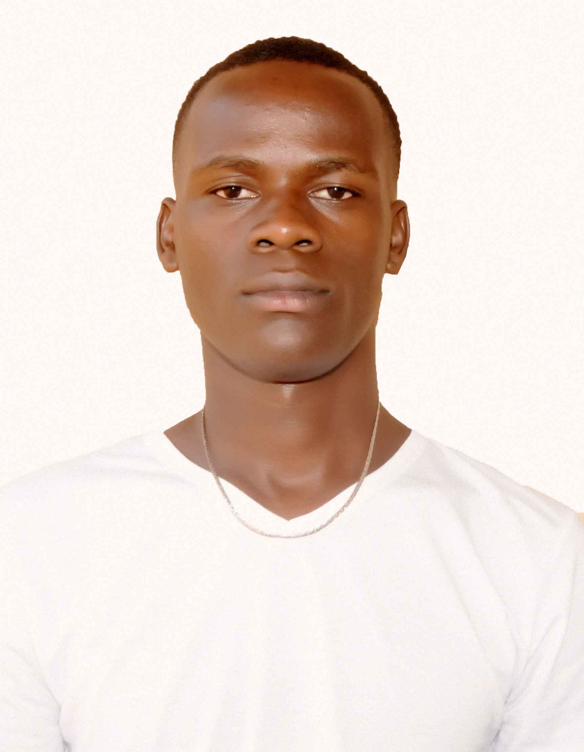

**BIO DATA**

**NAME:** ATEGEKA PATRICK

**SEX:** MALE

**NATIONALITY:** UGANDAN

**D.O.B:** 30th December, 2000

**MARITAL STATUS:** ENGAGED

**RELIGION:**  ANGLICAN

**ABOUT ME**

An open minded, quicker learner with enthusiasm about learning new things Self-drive for working hard with minimum supervision Goal oriented and ever demanding the best from myself in all situations. I am passionate about team work and doing a good job. Seeking an opportunity that will allow me to exploit my knowledge and transfer academic experience into work

**CONTACT**

**Address:** BULIMA TOWN COUNCIL, MASINDI DISTRICT

**Tel:** +256788121853/+ 256776636323

**Email:** [**ategekapatrick719@gmail.com**](mailto:ategekapatrick719@gmail.com)

**EDUCATION BACKGROUND**

|  |  |  |  |
| --- | --- | --- | --- |
| **DATE** | **INSTITUTION** | **QUALIFICATION** | **AWARD** |
| 3rd August,2024- current | KYAMBOGO UNIVERSITY | BACHELORS OF INFORMATION SYSYEMS | BACHELORS |
| 2022-2023 | Masindi Army Secondary School | Uganda Advanced Certificate Of Education **(UACE)** | Certificate |
| 2017-2020S | Masindi Army Secondary School | Uganda Certificate Of Education **(UCE)** | Certificate |
| 2009-2016 | Bulima Primary School | Primary Leaving Examination (PLE) | PLE Pas-slip |

**WORKING EXPERIENCE**

|  |  |  |  |
| --- | --- | --- | --- |
| **DATE** | **INSTITUTION** | **POSITION HELD** | **RESPONSIBILITY** |
| 5th August2024-current | KYAMBOGO UNIVERSITY | Leaner | WEB DESIGNER |

**HOBBIES**

* Research
* Games and sports
* Travelling
* Website development and designing
* Consultation

**LANGUAGES**

|  |  |  |  |
| --- | --- | --- | --- |
| **LANGUAGE** | **SPEAKING** | **READING** | **WRITING** |
| English | Excellent | Excellent | Excellent |
| Runyoro /Rutooro | Excellent | Excellent | Excellent |

REFEREES

1. Name: Tumusiime Keith

Position: Data base Administrator

Organization: UNITED BANK OF AFRICA(UBA)

Contact: +256781363816/+256755463395

Email: keithtumusiime@gmail.com

1. Name: MURUNGI MARVN

Contact: +256786916501/+256741896515

Email :

**DECLARATION**

I **ATEGEKA PATRICK** hereby affirm the above information is provided by me and is real.

**Date: 31st October, 2024**